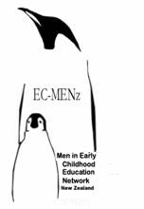
Men in Early Childhood Education Incorporated (NZ)
EC-MENz THIRD ANNUAL SUMMIT
“Creating and maintaining a male friendly environment in ECE Centres”
Dunedin, New Zealand, Saturday/Sunday February 14-15 2009

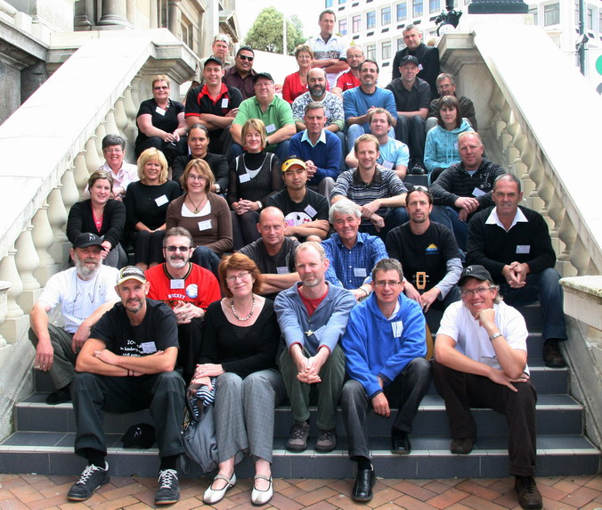
A report compiled and written by David Baxendell
EC-MENz inc.(NZ) March 2009
With grateful acknowledgement of the sponsors for this Summit.



Men in Early Childhood Education Incorporated (NZ)
EC-MENz THIRD ANNUAL SUMMIT
“Creating and maintaining a male friendly environment in ECE Centres”

The Third Men in ECE Summit was well attended, with representatives from most regions. A noteworthy and welcome aspect was the attendance of a significant number of women, and representatives from the MOE, ECE Training Establishments and Centre owners. This confirmed the growing interest and concern about this area from an increasingly wide population within the ECE field.
A valuable aspect of this Summit, not covered by the report was the valuable networking, camaraderie and sharing of ideas which occurred outside the main format of the Summit.
A special thanks to the City of Dunedin for providing the magnificent venue in the very centre of the City.
We all went away with our minds buzzing with ideas and a new resolve to tackle them.

DAY 1 - Saturday 14th February 2009

The Summit began with a mihi whakatau which set the spiritual tone for the next 2 days and placed the focus on our purpose being for the benefit of children, first and foremost.

Welcome address from Russell Ballantyne, President of EC-MENz inc.
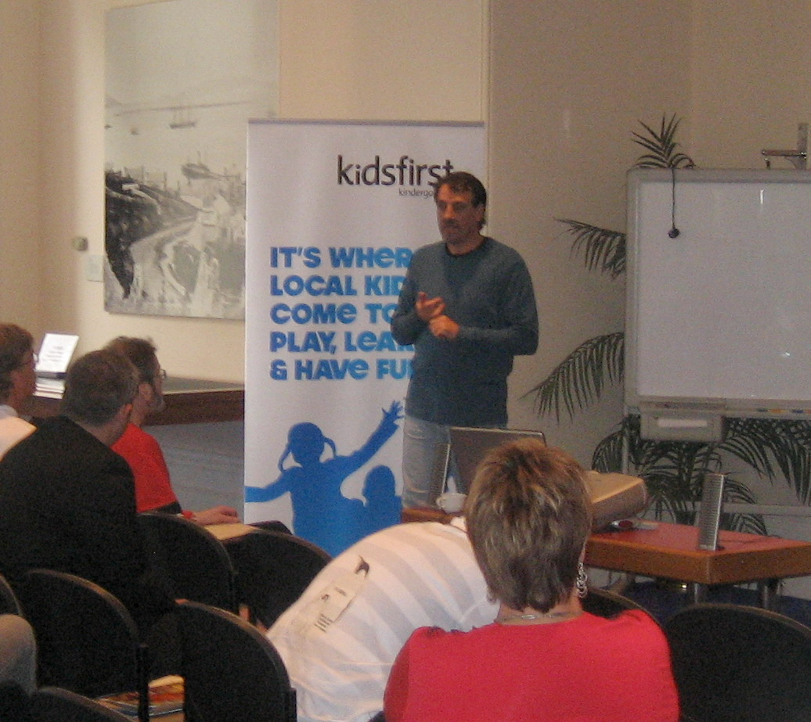
Russell welcomed our guest speakers and outlined some of the events of the last year, including the frustration of a lack of the necessary funding to achieve some of our goals set at the last Summit. However, the long awaited approval of EC-MENz inc as a charitable organization has now freed us to apply for funding in the future. He expressed our continuing disappointment that there seemed to be a lack of will at the top to actively target the recruitment of men into ECE, particularly in the light of current international practice showing this to have very successful outcomes.
“I also am very cognisant of parental views on this issue and ask where do their needs be met? What Choices do parents have in our early childhood education system to have their child taught by a male? Where do they take their children to build affective relationships with men? The answer is “nowhere”, as this is not catered for. Our own Curriculum states, throughout its underpinning principles, that children will develop relationships with adults – not only women but men – but again where in our centres does this happen?”
Russell recalled that one of the objectives from the 2008 Summit was to appoint a part time CEO to attend to the day to day operations of our organisation and to provide a continuous link to our members and the ECE sector. With the possibility of funding being raised this year this has become a possibility, whose importance has been emphasised over the year by the amount of work required of a small committee who have many other obligations. He warned that there was no point in having a CEO without an active and committed membership to provide focus in order to “truly address the inequalities that face our children and their families/whanau in terms of gender models and programming choices”.
“It is from our actions that ECMENZ will be measured and it is action that will put more men into the sector to grow the skill bases, talents and experiences of our early childhood teachers. So the question each and every one of you should be asking is what can I do to make it better?”

(see appendix i for the full text)

Professor Helen May
A Man’s Idea: philosophical and pedagogical traditions of
ECE

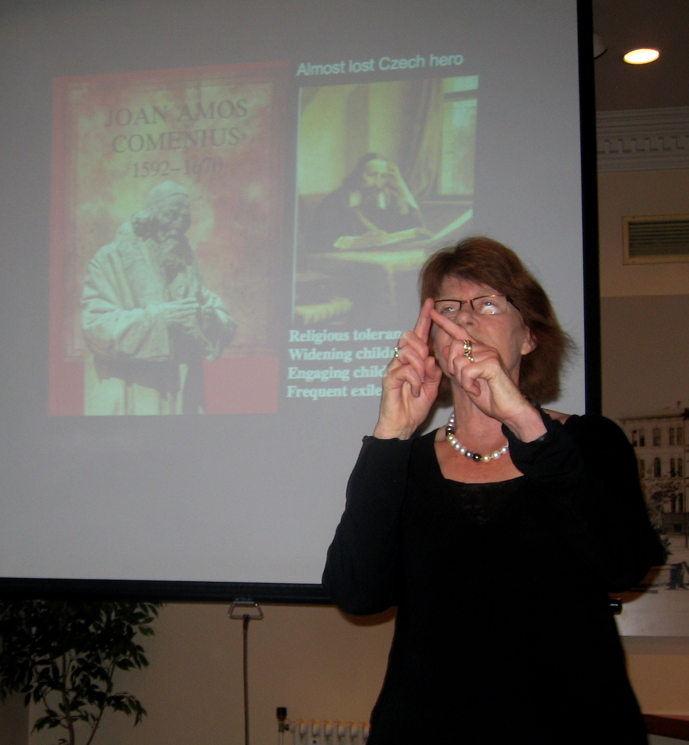

Helen May walked us through a fascinating history of early childhood education with an emphasis on the men who were instrumental in developing the concepts and theories whose influence shaped the ECE field today. Some, such as Rousseau, Pestalozzi, Froebel and Dewey, were familiar to us, though many of the details of their lives which Helen revealed were not. Others were less well known; Joan Comenius, Thomas Coram, J.F. Obelin , Robert Owen, and William Cadogan.
One of the interesting features of these men’s lives was that many of them were ridiculed, or in fear of their freedom or lives, for their radical philosophies, yet retained the courage and commitment to follow them throughout their lives.
Dr. May discussed how the feminization of education came about through the establishment of the Dame Schools, and the subsequent deterioration of status for Early Childhood.
No reira, e nga tane, kia kaha, kia toa, takatū i a koutou mo te riri.

Richard Walley
Senior Policy Manager, Ministry of Education, Wellington)
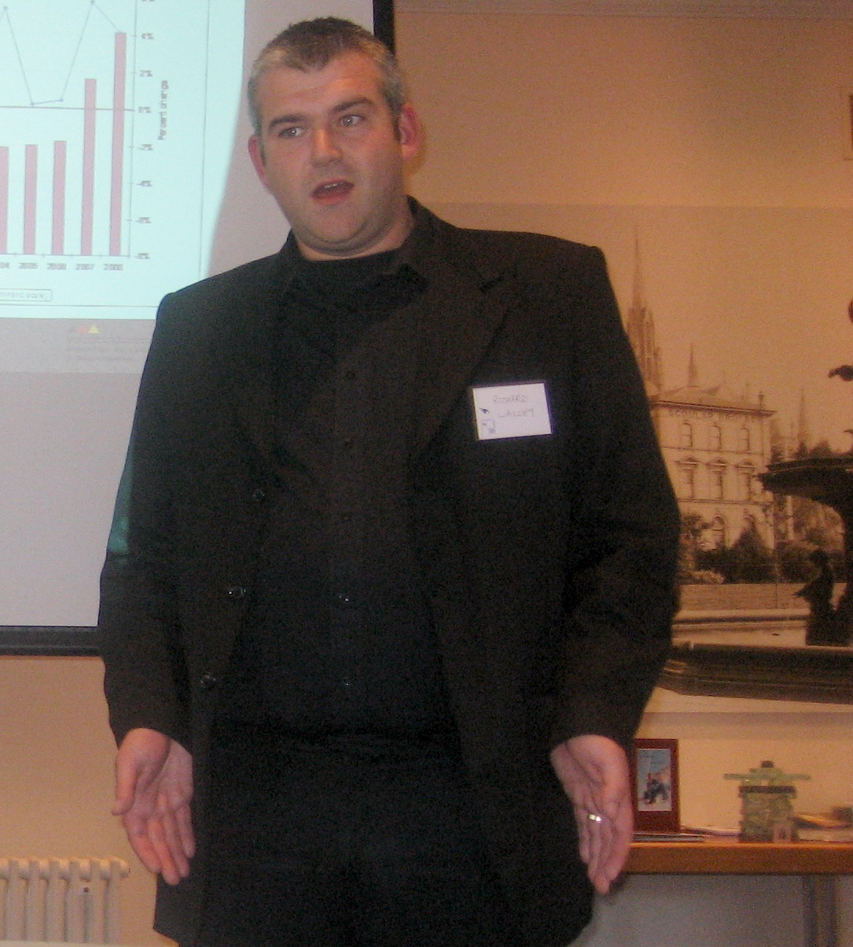
Richard made it very clear after introducing himself, that there were things he couldn’t tell us, “I don’t know”, or wouldn’t tell, “not yet official policy”. His approach was good-humoured, sympathetic to our agenda, and highly informative.
He showed us the statistics which indicated why, until recently, a big surge in the birth rate had dominated planning for ECE.
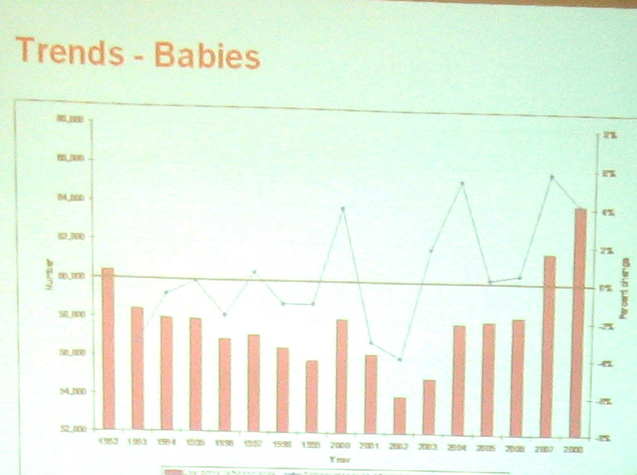
The Ministry’s estimate is that NZ will need another19000 child places (400 centres) in ECE to maintain current rates of participation and also bring Maori & Pasifika rates up to same level of participation. This trend, however, has now been equaled in priority by the challenges presented by the sudden economic downturn. This is beginning to impose a climate of fiscal restraint across the ECE sector. Therefore, although the Government objectives stated below remain paramount, achieving them will require an interesting juggling act.
Current plan:
- Enhancing “20 Hours ECE”
- Teacher shortages
- Reducing staff ratios
- Reducing bureaucracy and regulations
- Boosting participation

Enhancing “20 Hours Free”
- Keep existing subsidies and fee controls
- Remove the 6 hours a day limit
- Include playcentres and kohanga reo
- Include 5 year olds (along with 3 and 4 year olds in the present scheme)

Tackling teacher shortages
- Enhance the EC teaching degree with a series of modules that will:
- Promote working while training
- Allow qualified English speaking foreign teachers to qualify after intensive 6 week programme
- Allow Montessori, Steiner and Playcentre qualifications to count towards the degree

Reducing staff ratios
- Increase the adult/child ratios for U2 from 1:5 to 1:4
- After 2012 sessions for the U2 in teacher led EC centres are staffed by at least 50% qualified teachers

Reducing Bureaucracy & Regulations
- Remove unnecessary regulations over time
- For example, we will drop the requirement for early childhood centres with more than 50 children to have more than one licence

Boosting Participation
- Work with community groups, private centres, home-based providers and local government
- Develop local solutions that meet the needs of the EC centres in our communities

What does this mean for Men in ECE?
Men in ECE (October 2008)
2001 2008
Proportion of Male teachers 110(1.08%) 221(1.3%)
Proportion of Female teachers 10,123 16,640
TOTAL ECE teachers 10, 223 16,861

The number of Male teachers in ECE has doubled in the last 7 years, but because the total number of teachers has increased, the proportion of male teachers remains little changed.
As was pointed out from the floor, an increased demand for ECE teachers combined with increasing unemployment provides an ideal time for recruiting men into the field as they look for upgrading or changing their skills to enable them to work in relatively secure employment. Richard agreed, but pointed out that in the current economic climate, any initiatives would need to be carefully formulated to fit into the current objectives, as there was likely to be little discretionary funding from the Ministry.
Richard’s personal impression, garnered from close contact with other policy makers in the Ministry, was that the time was ripe for a large increase of entry and participation of men in ECE, not only in New Zealand but over a large part of the world. The EC-MENz target of 10% in 10 years may well be achievable, but it would be an incremental movement gathering pace as that time progressed. “There’s a tipping point when a society’s priorities achieve a critical mass, and there is a sudden flip-flop in attitude, rather like the anti-smoking campaign.”
Richard encouraged us to continue to strongly advocate our mission. We are being heard and noticed. There is a strong level of support for us out there. He and his colleagues at the Ministry will support us as fully as they are able within the constraints that they are given.

Ron Blatz
Executive Director, Discovery Children’s Center, Winnipeg, Canada
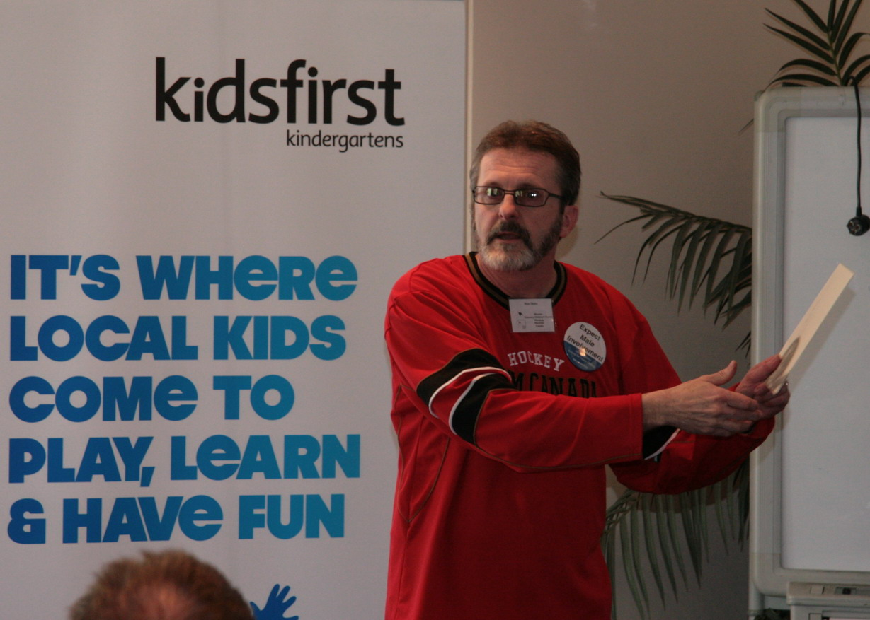
Ron was our keynote speaker. We had chosen him because of his initiatives in his home center and State to increase the participation of men working in ECE. Also as a representative at the 2008 Working Forum on Men in ECE in Hawaii, he would be able to share some of the insights he gained there.
During his self-introduction he shared with us how, although he was involved with ECE for 30 years, it was only when attending the previous World Forum in Kuala Lumpur that he had realized that in order to involve men in ECE in his Center and Region, that he needed to make a personal commitment and take action to make this happen.
Ron accompanied his presentation with some great stories and examples to illustrate his points. He pointed out that the organization of preschools in his native Manitoba differs somewhat from New Zealand, being primarily charitable organizations supported by and regulated by the Provincial Government. Employees can range from fully trained teachers, untrained assistants and those in ongoing training. However, he felt that the points he wished to cover would have universal relevance. His own Centre is the largest in Manitoba and is home to over 300 children cared for by 12 male and 32 female staff. Programs include Nursery School, Infant, Pre-School and School-age programs, an extended hour program and a Christian Pre-School Unit.
The April 2008 statistics for Manitoba showed that out of 5685 in the ECE workforce, there were 257(4.5%) men, and of these only 49(0.85%) were trained teachers. Returning from the World Forum on ECE in Malaysia, Ron began to wonder “Where are all the men?” They certainly weren’t applying for the positions he advertized for his centre. Thinking about this he came to the conclusion that men would look at his adverts and automatically assume that they were aimed at women. For 27 Years he had taken a generic gender neutral approach to recruitment which had never produced a gender balanced workforce. In May 2008, Ron placed a newspaper advertisement in the General Category and not in the Early Childhood section.
It read:
“Looking for a few good men with the courage to work in Child Care. Discovery Centre believes gender balance is good for young children. Interested? Call Donna or Ron at…”
“To my astonishment we had 30 men inquire about the job. I was stunned and overwhelmingly pleased to know that in Winnipeg there were more men than I could have imagined interested in this line of work.”
As a result Ron now employs 12 men on his staff of 42. This success led Ron to look at other issues facing the recruitment and retention of men in ECE.
- He set up a support group for men in ECE in Winnipeg, who meet regularly to share stories, build friendships and support each other in the struggles that men as a minority group can face in their places of employment. On most occasions they also invite their female counterparts to join them in order to have a more balanced and full discussion on the issues of men in ECE.
- He piloted a Canadian MECE “Club 2-10” All 57 club members are Centre Directors who have committed themselves to doing everything in their power to employ at least 2 men by the year 2010.
- He shared his vision with the Provincial Government which led to the province of Manitoba writing into their “Family Choices – Five Year Agenda for Early Learning and Child Care” the goal of improved efforts to recruit men in ECE
- Developed a brochure that gives some visibility to the MECE issue in Manitoba.
- Joined the leadership team that planned the World Working Forum on Men in ECE in Hawaii in 2008. This team continues to provide leadership for a fledgling international movement to encourage more men into the ECE field.
Ron proposed a number of strategies to create a male friendly environment and to recruit more men:
Creating male-friendly environments:
- Review policies to make sure that they are gender neutral and use language free of gender bias.
- Set the tone that men are welcomed and supported, especially if you are the director.
- Avoid assigning roles only based on gender
- Think about your own attitudes and what you can do to be more accepting of men in the field.
- Match male staff with mentors
- Encourage participation with support groups, networks or mentoring outside the centre.
Recruiting more men:
- Make active recruiting of men a goal
- Write ads aimed at men or that include “men encouraged to apply”
- Put ads in columns or publications read by men.
- Offer incentives to staff who recruit male staff.
- Encourage male work-experience placements from your local High School
- Target men changing careers.

There followed an interesting and positive discussion between Ron and the attendees regarding the perceived “feminization” of ECE. Attitudes towards, and expectations of children of both genders tend to be viewed from a female perspective, and which have been so thoroughly established that they are assumed to be the only way.
Some of these approaches were challenged strongly during this discussion. They were revisited and covered again more fully in the general discussion sessions he following day.
Ron concluded his presentation by exhorting us to continue with our work with renewed enthusiasm and focus. He hoped dearly that one day he would see a similar network to ours in pace in Canada one day.
Ron presented EC-MENz with an Inukshuk, a model in glass and stone which represents the traditional Inuit waymarkers.
DAY 2 - Sunday 15th February 2009

Issues that impact on men in ECE- a group discussion
- Elements of risk in children’s play
Male staff tend to encourage and be more accepting of children being involved in risk taking activities. “Yes, they might get hurt. That’s part of learning. Our responsibility is to see that they don’t get injured!” Playfighting and rough play is acceptable within the context of definite rules for physical and emotional safety being set and respected.

- Active play.
Men tend to be more encouraging of active and sports play. Should competitive play be encouraged? Physically active play tends to encourage children to discover their own limits within their play. Male staff should be given opportunities to discuss and contribute their perspective to changes within the indoor and outdoor environments

- Superhero play and gun play.
Everyone (men and women) in the group put up their hands when asked if they had ever played pretend gun games as a child. Children need heroes. Is Superman any worse than Barbie? Our play policies seem to stem from the anti-war movement of the 70’s. Some centres allow gun games but have clear and established rules for pretend weapon play. Submit articles to the Education Gazette around gun play

- Policy/rules around touching etc
Can some national policy be established about acceptable touch, changing procedures etc., so that all centres have an official basis to work from?
We could look at Ron Blatz’s touch policy as a model.
- The term “staff” should be used more strategically – male staff and female staff sends the message that the centre is gender balanced
- Use of appropriate language in centres between staff/teachers
- Feeling of “not being accepted” or alienated/isolated
- Parent contribution and input is important
- Gender balance within centres should be the focus
- The view of men within society – violent, no positive role modelling etc.

Proposed dates for next summit:
AUT – 2010
Feb 13th – Feb 14th

2009 AGM for EC-MENz Inc.
A quorum was declared and the Annual General Meeting was held.
Minutes of the AGM, reports and election of offices are available on the EC-MENz website:
www.ecmenz.org
(see appendix ii )
Discussion - Open Forum
What are the key things we need to achieve this year?
Strategies for 2009
- Funding/Fundraising
We need to obtain substantial funding to achieve our objectives. How will we do this? Need to have proposals for specific objectives costed in order to apply for funding. Now we have charitable status this should prove easier to achieve but economic situation will provide a challenge.
- Fundraising must be a priority to:
  - Clear existing debt
  - Fund CEO to manage day to day operations – one day per week
  - Allow EC-MENz to fulfil objectives and be present at conventions,
  - working parties

- CEO
Workload on committee is too great, with their other full time commitments. A part-time CEO would co-ordinate and initiate EC-MENz projects. Would need to be paid via funding from EC-MENz. Committee to discuss and come up with parameters, pay and hours.

- Develop EC-MENz stationery, letterhead, business cards etc.

- Develop Men in ECE internationally
Continue to develop our co-operation and visibility in the ECE field worldwide.
The website is a vital instrument in this.

- Institutional Membership
Create a membership category for Institutions such as KA, Te Tari Puna, ECC, NZE and ECE Trainers and Centres to develop relationships with them and to keep them informed.

- Develop advertising for EC-MENz (pamphlets, billboards, notices in Education Gazette, Childspace Magazine, etc.) Our own magazine?

- Own website – forum,
Continue to develop and promote ecmenz.org as our primary interface with the world and with members. Need to transfer ownership of the domain name and website hosting from David to EC-MENz now that we are incorporated. Look at Facebook as an extra option.
- Attend National and International Conferences to have an EC-MENz presence and input

- Develop a charter

- Career promotion.
Target individual schools Careers nights. Develop relationships with their careers advisors and get info to them. Target Regional career days –eg. Otago Careers Month, May 2009 and work experience days – eg APPROACH Learning Centre

- Recruitment and Retention in Training
Establish and develop links with training providers in each region, request information about what strategies they have found successful (or not) for recruiting men into ECE training. What would they like from us? (link to developing and costing project proposals for funding applications)
Contact and liaise with TeachNZ and MSD.
Develop liaison with WINZ for second choice careers

- Become involved in Centre Of Innovation Project with Ministry

- 2010 EC-MENz Summit
To be held at AUT Auckland Feb 13th – 14th . Planning to begin immediately. Establish a focus.

- Develop inventory of local research
Contact Sarah Farquhar to try to find out how we know who is doing what in terms of men in ECE.

- Acknowledging the employers
Ensure that we send acknowledgment and thanks for any support and employment initiatives by employers.

Making our centres more “male friendly” - consider the following reflective questions:

- Does the centre celebrate the role of men in the lives of young children?
- Are male and female teachers encouraged to be who they are with their inherent differences encouraged to celebrate their diversity?
- Are male teachers introduced to new parents and visitors in a positive way?
- Does your centre display pictures of men in early childhood both as fathers and teachers?
- Does management consult with male employees over policy /pedagogy such as “touch”, “physicality of play”, and what constitutes “authentic learning”?
- Does management consult with male employees over the “learning environment” in terms of learning preferences and experiences e.g. construction, technology and emphasis on outdoors?
- Are males encouraged to bring new ideas to the teaching team and to share their learning preferences?
- Does management expect the same of all employees in the teacher role such as toileting, changing, application of sunscreen, opening and the closing of centre and comforting children?
- Does the staffroom reflect both men and women in its provision of space and reading materials?
- Is gender similarity/differences openly discussed in staff meetings?
- Is there an open-ness to being accountable to one another for gender limitations imposed upon each other?
- Do we treat men and women the same in terms of expectations of behaviour including the objectification of the opposite sex?
- Does our policy make specific reference to both male and female teachers so that prospective parents expect male participation?

Appendix i
Address by the President of EC-MENz Incorporated(NZ), Russell Ballantyne, to the EC-MENz Third Summit, Dunedin 2009

Te Whanau
EC-MENz Incorporated) (NZ)
Tena koutou, tena koutou, tena tatou katoa
Nga Mihi nui. Nga Mihi mahana
Tena koutou, tena koutou, tena tatou katoa

A special welcome to Ron and Chris Blatz, who have voyaged across the globe from their home in Winnipeg. Ron has agreed to travel down here to share the stories from his region of Canada and to outline the ways he has been instrumental in the recruitment and retention of male teachers in his centre in Canada. We look very forward to his presentation and his contribution over the next two days. We also welcome Professor Helen May who will highlight the historical influences that males have had in this sector and perhaps this will lead to the question “Why has male influence and participation become so absent over the past century?”
We also welcome Richard Walley from the Ministry of Education who has agreed to attend and deliver a “state of the nation speech” and I am certain that this will be of extra interest considering the election of last year with a new rider at the helm.
So one year on – what has changed. This time last year when we met in Porirua we left with a sense of purpose and some ideas of where we as an organisation were headed. We had a committee of eight, a set of goals, and some great connections had been forged.
One year on we could state that despite these good intentions the year had not been successful as we had hoped. The election came and went and although we were able to get a hearing with Nationals Paula Bennet, the collective political awareness of our position was basically left untouched (despite the efforts of a brave and dogged few). We were able to meet with the Ministry and Teachnz, and although ideas were shared and offers of help were received, it rapidly became apparent that the issue of targeting men in recruitment drives for the early childhood sector was too “hot” and problematic. Whilst we were pleased with the offer of support and resources, the fact remains that New Zealand has this shameful statistic of men accounting for 1.2% of the early childhood workforce – one of the lowest participation rates in the western world. The lack of willingness to actively advertise in a concerted and overt way to attract men into our sector is in my mind scandalous and out of touch with international research including that of our presenter last year, Kenny Spence, whose work in Scotland confirmed the importance of men being invited into the sector. I am confident that Ron will also add weight to this point. At our meeting last year we invited TeachNZ and the Ministry to be confident in pushing for male recruitment as the non participation rate of males in the Early Childhood workforce was well known and obvious. As such an active recruitment campaign would be expected and applauded by most of those whom I am in contact with on a day to day basis, so I am intrigued as to where the heat of opposition lies.
There are many arguments in the debate about increased male involvement in early childhood. One frequent debate we hear is the fear that the standards will fall if we allow men into the service just because they are men. I am not aware of anyone in Early Childhood suggesting that we lower any entry systems or criteria to allow men in. We too want good teachers – but we believe that good teachers are both male and female. Perhaps what we do ask however is that we review the criteria and systems to ensure that they are attracting a diverse array of good teachers to match the diverse groups that use our education system – including both gender and ethnicity. Perhaps when the debate becomes more informed and looks at what has worked overseas to attract males then progress in achieving our 10% in 10 years will be made. Perhaps if we develop more of the inquiring mind that we seek in our children and investigate what are the barriers to men participating and then work at meeting these – then real progress can be made. To say it is too hard, too complicated is a cop out and a behaviour none of us would let go in the children we teach.
I also am very cognisant of parental views on this issue and ask where do their needs be met? What Choices do parents have in our early childhood education system to have their child taught by a male? Where do they take their children to build affective relationships with men? The answer is “no where”, as this is not catered for. Our own Curriculum states throughout its underpinning principles that children will develop relationships with adults – not only women but men – but again where in our centres does this happen?
We have three men in our centre working alongside ten women. Our children daily live with men and women working positively alongside each other, both learning and teaching together. They view men and women laughing, grumping , caring, loving, singing, reading, swinging, running – a whole gamut of actions that are shared, reproduced and delivered in their own way. They learn that both men and women can be fun, can play jokes, can be angry and can be kind, like singing and digging and some even can fit down the slide. Our parents, like our children, have a choice of who to approach, but this time there are men in the equation as well as women- big men, loud men and a quiet one , choice that most other centres do not have. Are we special – I don’t think so – it is the others that are lacking rather than us being special?
Who do the men go to? If we expect men to take an increased role in childminding where are the models out there for them? Who do they have to talk to about fathering? We talk loosely in our centres about parent support but should we not really call it mother support??? What about the male perspective of childrearing – where is the male view shared? Are our programmes truly representative of societal expectations and ideals or is there a dominant discourse in place here that values some learning over others. What do men think is important in programming and how do we know?

There is also the belief that the presence of men will reinforce traditional stereotypes which is in itself a contradiction of what we know to be the development of gender identity. We know that gender identity is fluid and is continually being constructed by the child in their immediate context. Therefore this would suggest the need to have a variety of males in the early childhood service to actually allow children to construct a more complex appreciation of gender – the absence of males would in fact limit a child’s view of masculinity rather than develop that. If we want our children to see the options available to them in terms of gender then surely it is important that they have multiple models to develop that from. And how can we really have this debate when men are not in the sector to have their voices heard? Who speaks on their behalf?
Another barrier often put at the feet of males is the fast promotion they have through the career structure. Again this is a system issue and hardly one to lay at the feet of men. If our appointments process is advantaging one group over another then it is surely time to look at those processes – especially with the number of employers who purport to be EEO employers.
However I digress – Back to 2008 .....One of the biggest barriers to develop in the past year has been the lack of the financial base to operate from. This raises a conundrum - to be influential you need to have a presence and to have a presence this invariably costs. Our committee was able to attend meetings in their own region including the AKA centenary and various other meetings. Whilst the Education Ministry funded airfares for myself to attend a meeting in Wellington, all other costs had to be met by the committee themselves which severely dented our ability to be heard. This seriously needs to be addressed so we as a Society can achieve our aims as stated in the constitution.
This issue was further highlighted by the time commitment and geographical challenges that took their toll on the elected committee. We lost the services of Peter Visser our vice president and work commitments severely dented Bernard Woodham’s ability to participate in the many Skype sessions we held during the year. The technology component also meant we very quickly lost connection with Garth Armstrong as the year progressed.
However the remaining members were enthusiastic and incredibly dedicated to our goals and I take this time to acknowledge the valuable support of Simon Easton, David Baxendell and Robin Christie. These three men were committed to ensuring we as an organisation progressed and worked tirelessly promoting ECMENZ incorporated to their colleagues, friends and contacts. It is no surprise that we have KidsFirst Kindergartens as a major sponsor and I thank both them and David for their presence today. It is these contacts which result from a strong will coupled with a dogged determination that will ensure that our message reaches the sector. I hope that many here today will leave with a similar resolve which will result in the sector not only demanding action, but taking action. It is through the voice of members such as you that the gateway to change will be opened and the pathway defined.
I pause now to acknowledge the role that my Centre, Early Childhood on Stafford, has taken to support this cause. We have not only walked our talk – we have danced it and I only hope that others will soon embrace this cause with as much commitment at centre level as we have. In particular I wish to acknowledge my business partners Robyn and Sue who have not only supported but encouraged my participation and have carried the workload in my absence. I acknowledge the presence of our staff here today who have joined us to learn more and am proud of their support of an issue that is less of an issue in our centre than most.
I also need to acknowledge the intense work that Anthony Keesing has been doing for us behind the scenes. Anthony has many contacts and works for a number of organisations wearing many different hats. He has supported ECMENZ throughout this year and his commitment to our cause can never be undervalued. He has been a great source of support for me personally and men in early childhood in general.
Ok so what has been successful over the last year? We have successfully become an incorporated society and now after 9 months of delay and procrastination we have finally been awarded charitable status. This process was incredibly important and hopefully will help address the financial base issue. As stated previously we need financial support to operate successfully and we can now apply for funds from various sources to achieve this. If we are successful in achieving funding this will not only allow us to be where we should be in terms of influence groups in ECE but will also help share the workload on the members. One of the aims from the 2008 summit was to appoint a CEO to attend to the day to day operations of our organisation and to provide a continuous link to our members and the ECE sector. The need for this became even more apparent as the committee members fell into absence zones depending on the day to day challenges they faced in their own careers. We must seek to protect ECMENZ from a haphazard, piecemeal availability if we are to truly address the inequalities that face our children and their families/whanau in terms of gender models and programming choices and a CEO will help address this.
However, I also warn there is no point having a CEO if we don’t have an active membership. We have moved from an email list of 160 to now ECMENZ Inc. membership of 80. Already we have lost members and we need to be proactive in achieving growth. Where have these people gone? And why have they lost interest? These questions need to be answered and again this is up to us as a group to face these challenges. It is too easy to come together each year and discuss the inequalities and then disappear into the fog for another year without making a contribution. It is almost like the Judean People’s Front discussion from the life of Brian on whether Reg can have babies, and whilst we can argue the rights and wrong – it is the action that counts. It is from our actions that ECMENZ will be measured and it is action that will put more men into the sector to grow the skill bases, talents and experiences of our early childhood teachers. So the question each and every one of you should be asking is what can I do to make it better??
The challenge now is to face 2009 with a new determination to make a difference. I call upon all sectors of ECE to support our intention of having 10% of the workforce male by 2018. I ask that Government agencies monitor male involvement in pre-service training and work with our organisation to better help retain the men that have made it into our sector. I ask that pre -service trainers be more reflective in their practices and review the number of males that they are attracting into their programmes and set targets and strategies to increase male recruitment and retention numbers. There is no better time to make things happen than now – with the economic slowdown we know that when men are faced with employment uncertainty many then look to retrain and let us use this opportunity to make our sector richer.
So I welcome you all here today and look forward working with you over the next two days – this will be an important time in which we establish our pathway for the next year. It is important that we build the foundations to grow and to leave this Summit in the knowledge that we are all heading in the same direction. Our organisation already has much support in the sector – it is time we used this.

Thank you
Russell Ballantyne
President ECMENZ Inc

